SUPPLY CHAIN SALES & PROFITABILITY ANALYSIS

Title: Supply Chain Sales & Profitability Analysis
Prepared By: Rupjit Das
Tools Used: Python, Pandas, NumPy, Matplotlib, Seaborn
Dataset: DataCo Supply Chain Dataset

Executive Summary
This project analyzes sales performance and profitability within a global supply chain environment using the DataCo Supply Chain Dataset. The objective was to identify revenue drivers, evaluate profitability across products, categories, and markets, and assess the impact of discounting on overall business performance.
The analysis focuses on sales trends, profit trends, category performance, product performance, market performance, and discount impact. Through descriptive analytics and business intelligence techniques, key insights were generated to support strategic decision-making and improve profitability.
The findings provide valuable guidance for revenue optimization, product portfolio management, market expansion strategies, and discount policy improvements.

Business Problem
Revenue growth alone does not guarantee business success. Organizations must understand which products, categories, and markets contribute most effectively to profitability.
Key challenges include:
• Identifying top-performing products and categories
• Understanding profitability across markets
• Evaluating the impact of discounts on profit margins
• Monitoring sales and profit trends over time
• Improving overall business profitability
A data-driven approach is required to identify growth opportunities and optimize business performance.

Project Objectives
The objectives of this project are:
• Analyze overall sales performance.
• Evaluate overall profitability.
• Identify sales and profit trends over time.
• Compare sales and profitability across product categories.
• Identify top-performing and underperforming products.
• Evaluate market-level sales and profit performance.
• Analyze the impact of discounts on profitability.
• Generate business recommendations to improve revenue and profit margins.

Dataset Overview
Dataset Name: DataCo Supply Chain Dataset
Total Records: 180,519 Orders
Analysis Scope: Sales & Profitability Analysis
Key Variables:
• Sales
• Order Profit Per Order
• Order Item Discount
• Order Item Discount Rate
• Product Name
• Category Name
• Department Name
• Market
• Order Country
• order date (DateOrders)
Derived Variables:
• Profit Margin %
• Order Month
• Order Year
• Discount Bucket

Executive KPI Dashboard
10.78
Profit Margin %
3,966,902
Total Profit
36,784,735
Total Sales
559.45
Average Order Value

Interpretation:
The KPI dashboard provides a high-level summary of overall business performance. These metrics help management evaluate revenue generation, profitability, and operational efficiency.

Monthly Sales Trend
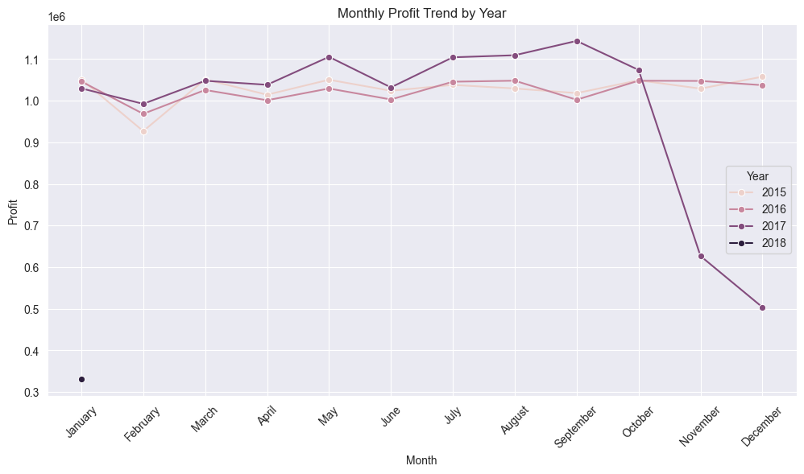Objective: To analyze revenue growth and sales patterns over time.
Observation
- Monthly profit remained relatively stable, ranging between 1.0M and 1.15M across most months.
- 2017 recorded the highest profitability, with a peak of approximately 1.15M in September.
- February shows a slight decline in profit across multiple years.
- A sharp decline is visible in November and December 2018, likely due to incomplete data.
Analysis: The business maintained consistent profitability throughout the analysis period, with 2017 being the strongest-performing year. Apart from a few seasonal fluctuations, profit levels remained stable, indicating healthy financial performance.
Business Impact: Stable profit trends suggest strong business sustainability and predictable financial performance. The superior performance in 2017 highlights opportunities to identify and replicate successful business strategies.
Recommendation: Investigate the factors that contributed to the strong profitability in 2017 and continue monitoring monthly profit trends to identify seasonal opportunities and risk.

Monthly Profit Trend
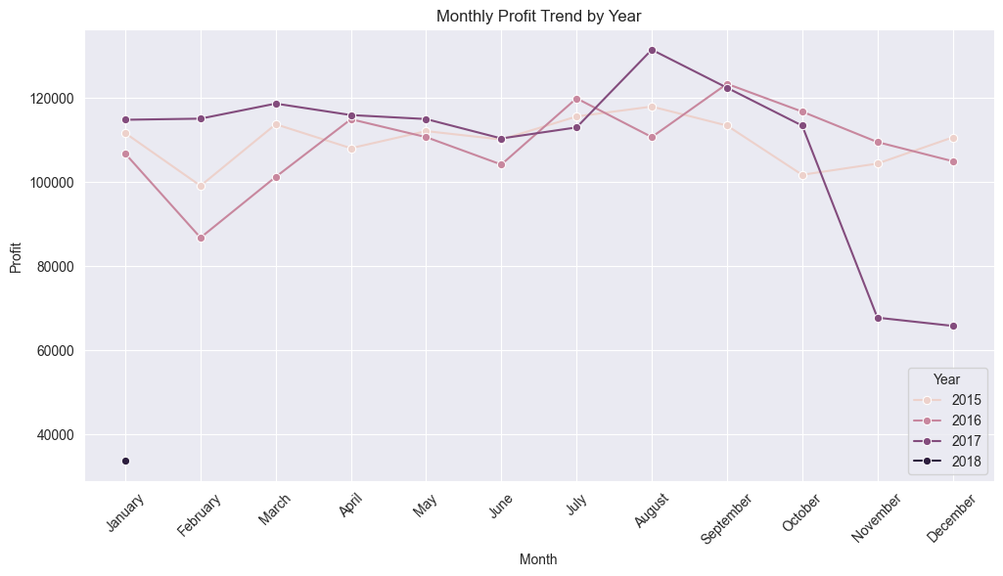Objective: To evaluate changes in profitability over time.
Observation
- Monthly profit remained stable between 100K and 130K across most months.
- 2017 recorded the highest profit, peaking at approximately 131K in August.
- 2016 showed greater fluctuations compared to 2015 and 2017.
- A significant decline is visible in November and December 2018, indicating incomplete or partial-year data.
Analysis: Profitability remained consistently strong throughout the analysis period, with 2017 outperforming other years. The overall trend suggests stable financial performance with only minor seasonal variations.
Business Impact: Stable profit levels indicate healthy business operations and predictable financial performance. The strong results in 2017 demonstrate the organization's ability to sustain profitable growth.
Recommendation: Analyze the business factors behind the strong profitability in 2017 and continue monitoring monthly profit trends to identify opportunities for improving performance during weaker months.

Sales by Category
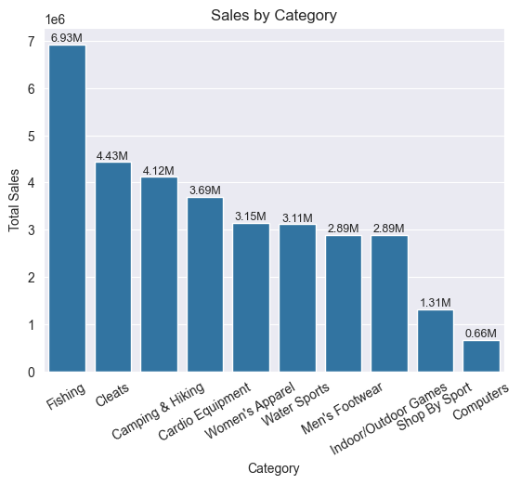
Objective: To identify product categories generating the highest revenue.
Observation
- Fishing generated the highest sales at approximately 6.93M, significantly outperforming all other categories.
- Cleats (4.43M) and Camping & Hiking (4.12M) were the second and third highest revenue-generating categories.
- Sales gradually decline across the remaining categories, with Computers (0.66M) generating the lowest revenue.
- Revenue is heavily concentrated within a few categories, while several categories contribute relatively smaller portions of total sales.
Analysis: The sales distribution is uneven across categories, indicating that a limited number of product categories drive the majority of revenue. Fishing dominates the category portfolio, while Computers and Shop By Sport contribute comparatively little to overall sales performance.
Business Impact: The business appears highly dependent on a few key categories for revenue generation. Any decline in demand within these top-performing categories could significantly impact overall sales performance.
Recommendation: Prioritize inventory management, marketing efforts, and product expansion within high-performing categories such as Fishing, Cleats, and Camping & Hiking. Simultaneously, evaluate strategies to improve sales performance in underperforming categories like Computers and Shop By Sport.

Profit by Category
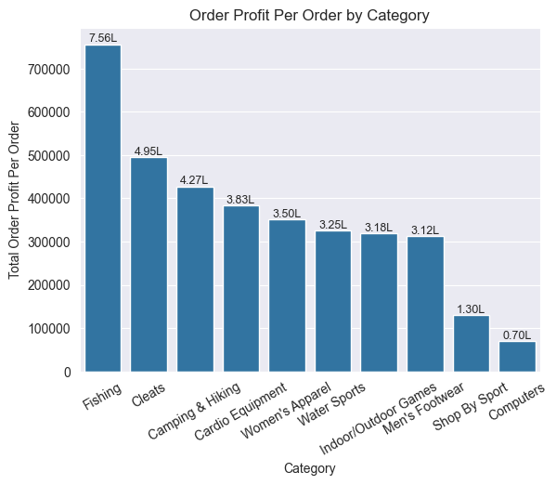
Objective: To evaluate profitability across product categories.
Observation
- Fishing generated the highest total profit at approximately 756K, making it the most profitable category.
- Cleats (495K) and Camping & Hiking (427K) were the next highest profit contributors.
- Profit distribution closely follows the sales distribution, indicating that top-selling categories also generate the highest profits.
- Computers (70K) and Shop By Sport (130K) contributed the least profit among all categories.
Analysis: The results indicate that Fishing, Cleats, and Camping & Hiking are the primary profit drivers of the business. Categories generating high sales also appear to generate strong profits, suggesting that these categories maintain healthy profit margins while achieving high revenue volumes.
Business Impact: A significant portion of total profit is concentrated within a small number of categories. Strong performance in these categories is critical for maintaining overall business profitability and financial stability.
Recommendation: Continue investing in high-profit categories such as Fishing, Cleats, and Camping & Hiking through targeted marketing, inventory optimization, and product expansion. Additionally, review low-profit categories like Computers and Shop By Sport to identify opportunities for improving profitability or reallocating resources more effectively.

Sales vs Profit by Category
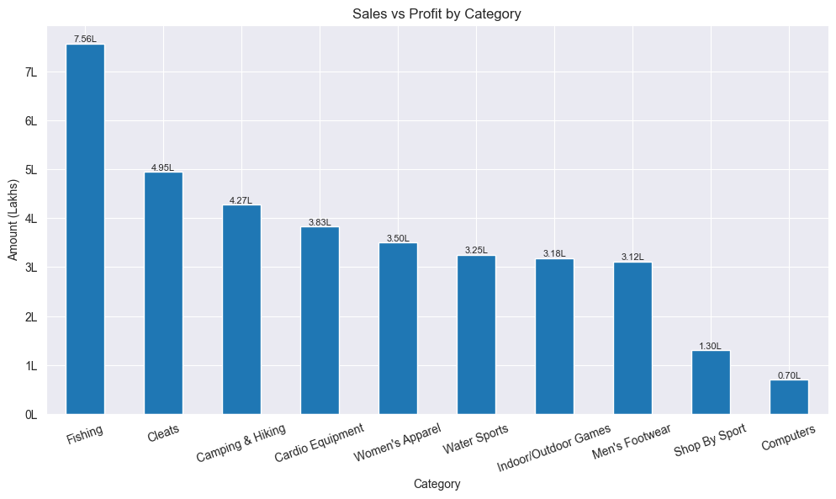Objective: To compare revenue generation and profitability across categories.
Observation
- Fishing is the strongest-performing category in both sales and profit.
- Cleats and Camping & Hiking are the next most significant contributors to business performance.
- Computers and Shop By Sport contribute the least revenue and profit.
- Sales and profit rankings are largely aligned across categories.
Analysis: The close relationship between sales and profit suggests that the highest-selling categories are also the most profitable. This indicates that the company's core product categories not only generate demand but also maintain healthy profitability.
Business Impact: The business relies heavily on a small number of categories for both revenue and profit generation. Maintaining performance in these categories is essential for sustaining overall business growth and profitability.
Recommendation: Focus marketing, inventory planning, and product development efforts on high-performing categories while reviewing low-performing categories for optimization opportunities.

Top 10 Products by Profit
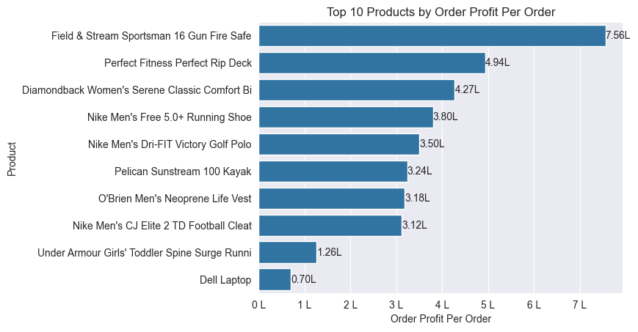Objective: To identify products generating the highest profit.
Observation
- The Field & Stream Sportsman 16 Gun Fire Safe generated the highest profit at approximately 756K, significantly outperforming all other products.
- Perfect Fitness Perfect Rip Deck (494K) and Diamondback Women's Serene Classic Comfort Bike (427K) ranked second and third in profitability.
- Several Nike products appear in the top 10 list, indicating strong profitability within the sportswear and footwear segment.
- There is a noticeable gap between the top-performing product and the rest of the portfolio.
- Dell Laptop generated the lowest profit among the top 10 products, contributing only 70K.
Analysis: Profitability is concentrated among a relatively small group of products, with the top-performing products contributing a significant share of overall profit. The dominance of sporting goods, fitness equipment, and outdoor products suggests that these product segments are key profit drivers for the business.
Business Impact: The business relies heavily on a limited number of high-profit products. Strong performance from these products directly influences overall profitability, making them strategically important for revenue and profit growth.
Recommendation: Prioritize inventory availability, marketing investment, and promotional efforts for high-profit products such as the Field & Stream Gun Fire Safe, Perfect Rip Deck, and Diamondback Bike. Additionally, analyze the factors driving their success and apply similar strategies to other products within the portfolio.

Top 10 Products by Sales
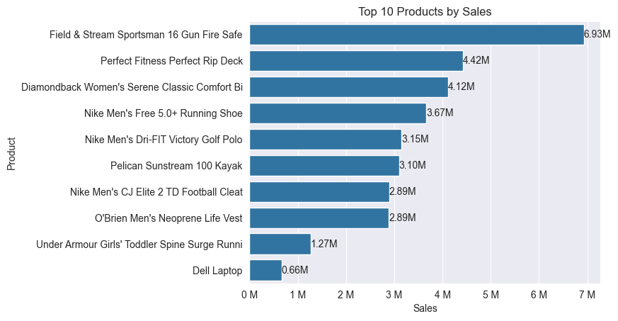Objective: To identify the products generating the highest revenue.
Observation
- The Field & Stream Sportsman 16 Gun Fire Safe generated the highest sales at approximately 6.93M, significantly outperforming all other products.
- Perfect Fitness Perfect Rip Deck (4.42M) and Diamondback Women's Serene Classic Comfort Bike (4.12M) ranked as the second and third highest revenue-generating products.
- Multiple Nike products appear among the top-selling products, highlighting strong customer demand within the sportswear category.
- The top three products contribute substantially more revenue than the remaining products.
- Dell Laptop recorded the lowest sales among the top 10 products, generating approximately 0.66M in revenue.
Analysis: Sales are highly concentrated among a small number of products, indicating that a limited set of products drives a significant portion of overall business revenue. The dominance of sporting goods, fitness equipment, and outdoor recreation products suggests that these segments represent the company's strongest revenue streams.
Business Impact: The business depends heavily on a few high-performing products for revenue generation. Any decline in demand for these products could have a significant impact on overall sales performance.
Recommendation: Maintain strong inventory levels and marketing support for top-selling products such as the Field & Stream Gun Fire Safe, Perfect Rip Deck, and Diamondback Bike. Additionally, identify characteristics shared by these successful products and apply similar strategies to increase sales across other product categories.

Sales by Market
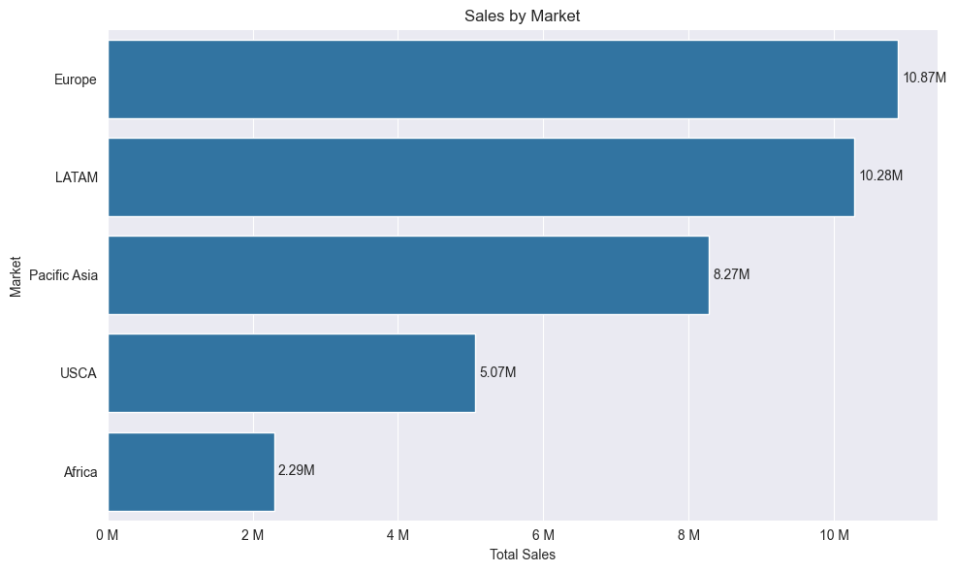Objective: To compare revenue performance across global markets.
Observation
- Europe generated the highest sales at approximately 10.87M, making it the strongest revenue-generating market.
- LATAM closely followed with sales of 10.28M, indicating a similarly strong market performance.
- Pacific Asia contributed 8.27M in sales, establishing itself as another major revenue source.
- USCA generated moderate sales of 5.07M, significantly lower than Europe and LATAM.
- Africa recorded the lowest sales at 2.29M, contributing the smallest share of total revenue.
Analysis: Sales performance is concentrated in Europe, LATAM, and Pacific Asia, which collectively account for the majority of total revenue. Europe leads the market portfolio, while Africa represents a relatively underdeveloped market in terms of sales contribution.
Business Impact: The business relies heavily on a few high-performing markets for revenue generation. Strong performance in Europe and LATAM plays a critical role in sustaining overall business growth and financial performance.
Recommendation: Continue strengthening operations and customer engagement in Europe and LATAM to maintain revenue growth. At the same time, investigate opportunities to expand market penetration and improve sales performance in lower-performing regions such as Africa and USCA.

Profit by Market
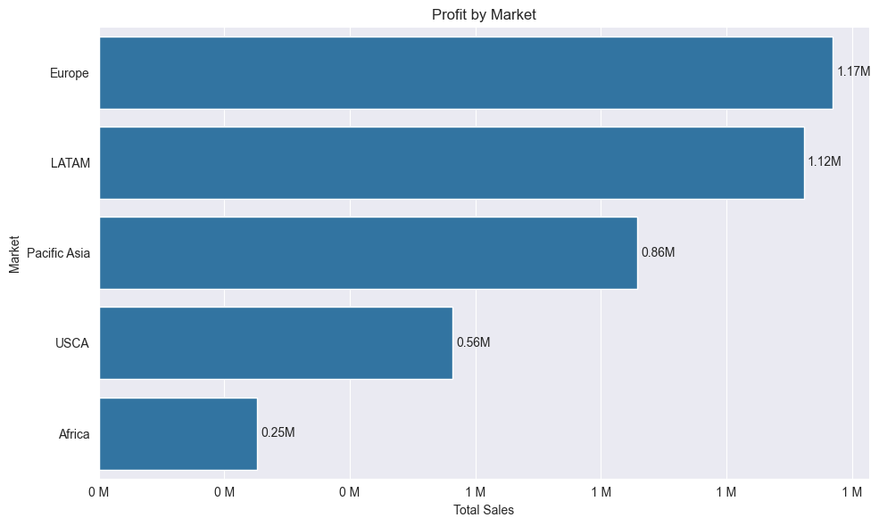Objective: To compare profitability across markets.
Observation
- Europe generated the highest profit at approximately 1.17M, making it the most profitable market.
- LATAM followed closely with a profit of 1.12M, indicating strong profitability.
- Pacific Asia contributed approximately 0.86M in profit and ranked third among all markets.
- USCA generated moderate profit of 0.56M, significantly lower than the top three markets.
- Africa recorded the lowest profit at approximately 0.25M.
Analysis: Profitability is concentrated within Europe and LATAM, which together contribute a substantial share of total business profit. The similarity between sales and profit rankings suggests that the highest revenue-generating markets are also the most profitable.
Business Impact: Europe and LATAM serve as the primary profit engines of the business. Their strong financial performance has a significant influence on overall profitability and business growth.
Recommendation: Maintain investment and operational focus in Europe and LATAM to sustain profitability. Additionally, investigate opportunities to improve margins and market penetration in lower-performing regions such as Africa and USCA to achieve a more balanced profit distribution.

Profit by Discount Range
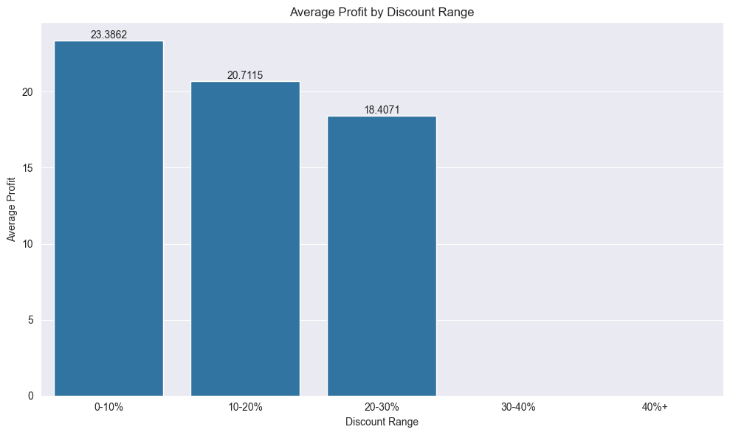 Objective: To measure profitability across different discount levels.
Observation
- Orders with 0–10% discounts generated the highest average profit of approximately 23.39 per order.
- Average profit declined steadily as discount levels increased.
- Orders with 20–30% discounts generated the lowest average profit among the available discount ranges at approximately 18.41.
- No orders were recorded in the 30–40% and 40%+ discount ranges.
Analysis: The results show a clear negative relationship between discounts and profitability. As discount rates increase, the average profit earned per order decreases. This indicates that higher discounts reduce profit margins and may not generate sufficient additional revenue to offset the reduction in selling price.
Business Impact: Aggressive discounting can significantly impact profitability. While discounts may help drive sales volume, excessive discounts reduce the profit generated from each transaction and can negatively affect overall financial performance.
Recommendation: Maintain discount levels within the lower ranges whenever possible and regularly evaluate promotional strategies to ensure that increased sales volume does not come at the expense of profitability. Focus on value-based promotions rather than deep discounting to preserve profit margins.

Profit Margin by Category
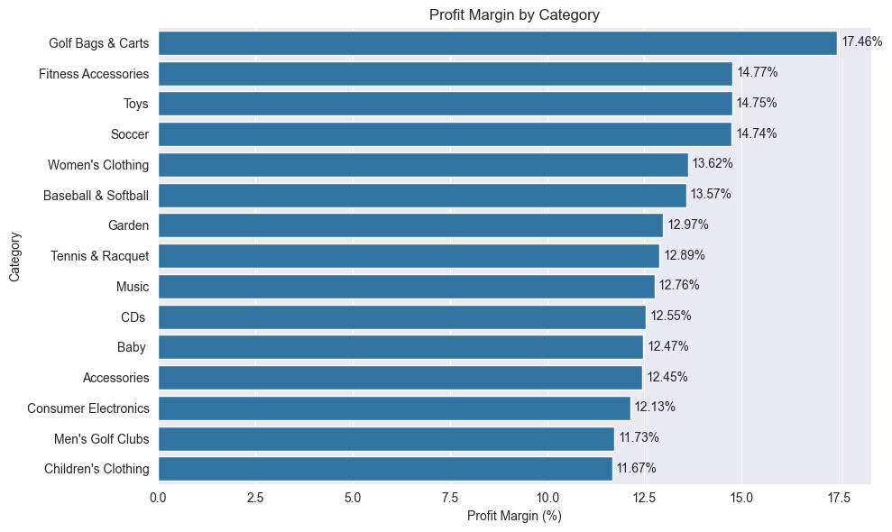Objective: To measure profitability by different categories
Observation
- Golf Bags & Carts recorded the highest profit margin at 17.46%, making it the most efficient category in converting sales into profit.
- Fitness Accessories (14.77%), Toys (14.75%), and Soccer (14.74%) also demonstrated strong profitability.
- Most categories maintained profit margins between 12% and 15%, indicating relatively consistent profitability across the portfolio.
- Children's Clothing (11.67%) and Men's Golf Clubs (11.73%) recorded the lowest profit margins among the top categories.
Analysis: While some categories may not generate the highest sales volumes, they achieve superior profitability through stronger margins. Golf Bags & Carts stands out as the most profitable category relative to its sales revenue, suggesting effective pricing, cost management, or product positioning.
Business Impact: High-margin categories contribute more profit per dollar of sales and can significantly improve overall business profitability. Focusing only on revenue may overlook categories that generate stronger financial returns.
Recommendation: Increase marketing and inventory investment in high-margin categories such as Golf Bags & Carts and Fitness Accessories. Additionally, review pricing and cost structures in lower-margin categories like Children's Clothing and Men's Golf Clubs to identify opportunities for margin improvement.

Key Findings
- Revenue is concentrated within a small number of product categories.
- Certain categories generate strong sales but relatively lower profit margins.
- A limited number of products contribute significantly to overall profitability.
- Market performance varies considerably across regions.
- Higher discounts generally reduce profitability.
- Profit margins differ significantly across categories.
- Revenue growth does not always translate into profit growth.
- Product-level profitability provides more actionable insight than sales volume alone.

Recommendations
- Focus investment on high-margin categories and products.
- Review categories with high sales but low profitability.
- Optimize discount strategies to protect profit margins.
- Expand operations in high-profit markets.
- Monitor low-performing products and evaluate discontinuation opportunities.
- Implement KPI dashboards for continuous monitoring.
- Prioritize profit-based decision-making rather than sales-based decision-making.
- Regularly evaluate product portfolio performance.

Conclusion
This project successfully evaluated sales performance and profitability using descriptive analytics techniques.
The analysis identified important trends across sales, profit, product categories, products, markets, and discount strategies. The findings demonstrate that sustainable business growth depends not only on increasing sales but also on improving profitability and operational efficiency.
The insights generated through this analysis can help organizations optimize product strategies, improve pricing decisions, maximize profit margins, and support data-driven business decision-making.

